Getting your section back together safely.

Risk Assessments and checklist for the return of face-to-face Scouting.

As we move to restart face-to-face meetings and activities, there are specific things you as leaders will need to do ahead of getting approval to restart. Face to face meetings cannot take place without the appropriate approval. Our number one priority is making sure that all our members are kept safe. If we don’t feel we can do that, we shouldn’t feel obliged to restart activities. This document is to be completed using the support guidance sent with it.

You will be required to complete a risk assessment and checklist for each Section. The stages for the approval of the risk assessments are outlined below. The checklist for GSLs to approve their risk assessments is here.

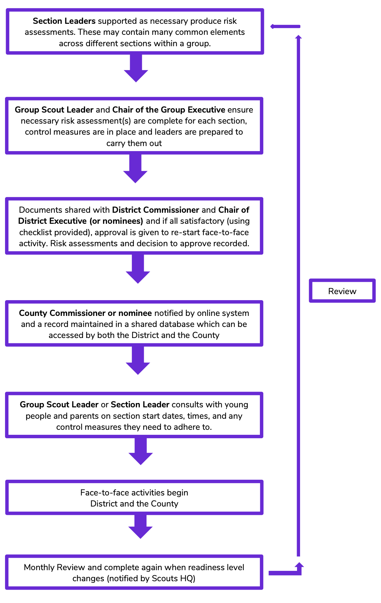
For your Group, the appointed District level
nominee to receive the documentation is;

Name;
Email;
Mobile:

You will be notified by email on the successful
submission of your risk assessment for each
Section. Once approved, you will be further
notified of any amendments or approvals.

Getting back together
safely: The COVID Code
1. A COVID-safe risk assessment has been
completed and we have communicated control
measures to volunteers, young people and
parents/carers, and all are encouraged to raise
concerns.
2. Additional hygiene measures are in place.
3. Social Distancing will be observed (check
current distance determined by your
Government).
4. Maximum group sizes will be limited and
determined by scouts.org.uk and members will
be consistent where possible.
5. Make adjustments for young people and
adults vulnerable or affected by COVID, and
consult to make sure return plans are accessible
and inclusive.

Leader checklist
This checklist is to be used to support the writing of the RA. If items are marked as a no, it does not mean automatic rejection of the RA but will form part of a conversation with the GSL/District Approver linked to the RA.

General
Have you read and understood the relevant guidance on the Getting back together safely webpages?

Have you incorporated hazards and considerations identified in the relevant guidance into your risk assessment?
People
Have you consulted with volunteers, parents, carers and young people (including Young Leaders)?

Do you have enough volunteers to run each session safely and within ratios?*
* Both government and POR requirements.
Are any volunteers or young people (or members of their household) vulnerable or shielding?
Have you talked with them and agreed appropriate adjustments to ensure they can still be engaged (where they wish)?
If you run multiple sessions for smaller groups, do leaders have capacity for extra sessions or would you extend programme activity in alternate weeks, with activities to be done at home for those alternate weeks?
Do the adult leaders meeting face-to-face have the appropriate;
- Up-to-date DBS checks (or renewing within the allowed 90 days)?
- Safety validation complete?
- Safeguarding validation complete?
- First Aid (where required)?
Have you agreed what to do if there is an incident, someone is injured, or shows signed of COVID-19 during a face-to-face meeting? Do all volunteers know what this is?
Have you got a way of recording all attendance for each face-to-face session, including adults and visitors / helpers (track & trace) and keep it secure for six weeks?
Have you produced a plan for how you intend to communicate with parents/carers?
Have you got a safe process for engaging and supporting any parents/carers/new volunteers who may have expressed an interest in volunteering?
Programme
Are there good quality programme activities on offer? Is the challenge appropriate for the section? Does the programme still support young people to achieve top awards? Can these be done socially distanced/blended with online activities?
If needed, are you able to ‘buddy up’ with other sections/groups to ensure you can deliver a quality programme safely? Are there other volunteers in the District/County who could support you?
Are you able to make sure any shared resources used (and surfaces and equipment) are kept clean, between users? Have you identified alternatives options (such as young people bringing their own)?
Is your programme flexible enough to be delivered both at home and face-to-face (as requirements allow)?

How can those who are unable to attend face-to-face still be included and engaged?
Places
Have you selected a proposed meeting place(s)/venue(s) for running your programme and considered how you can meet government guidelines? Including access consideration/drop off and pick up arrangements?
Have you considered what facilities may be needed for handwashing, drying, alcohol hand gel and toilet facilities?
Travel: How do volunteers and young people get to the venue? Is it within walking distance? Do people from different households usually car share or take public transport?
Have you produced updated risk assessments for each activity and setting?

Name of Section or Activity |  | Date of risk assessment |  | Name of who undertook this risk assessment |  | COVID-19 readiness level transition | Red to Amber

Hazard Identified? /  Risks from it? | Who is at risk? | How are the risks already controlled?  What extra controls are needed? | What has changed that needs to be thought about and controlled?
Hazard – something that may cause harm or damage.  Risk – the chance of it happening. | Young people,  Leaders,  Visitors? | Controls – Ways of making the activity safer by removing or reducing the risk from it.  For example - you might use a different piece of equipment or you might change the way the activity is carried out. | Keep checking throughout the activity in case you need to change it…or even stop it! This is a great place to add comments which will be used as part of the review.
We’ve provided some examples of hazards and potential control measures to help start your thinking on developing your risk assessment and plans for restarting face to face scouting. Make sure you customise all content in red so that it is relevant to your local situation and understood by those developing it and those reviewing it.

Maintaining social distance at drop off and pick up: higher risk of infection spread if social distancing not maintained. |  | Controls could include: clear expectations with all involved, stagger arrival and pick up times.
Maintaining social distance during meeting: higher risk of infection spread if social distancing not maintained. |  | Controls could include: limit group sizes to the volume of people a location can support with social distancing in place, maintain and mark clear space between groups, pre-plan how groups will be managed for each activity.
Hygiene of people: higher risk of infection spread if proper hand washing not carried out. |  | Controls could include: clear expectations with all involved, provide hand sanitiser/ hand washing for members on arrival, departure and during as required.
Hygiene of toilets: higher risk of infection spread if hygiene not carried out. |  | Controls could include: toilet facilities cleaned before and after sessions, cleaning equipment available to leaders with safe storage. Deep cleaning of the facility on a regular basis.
Hygiene of activity equipment: Higher risk of infection spread if hygiene not carried out. |  | Controls could include: cleaning of activity equipment before and after group use, assigning specific items to individuals for the evening, limiting volume of equipment used, including consumables such as paper.
Use of outdoor spaces: un-even ground, access to space less controlled, cannot be cleaned. |  | Controls could include: choice of location appropriate to activity, briefing to leaders and young people on boundries, checks on the location ahead of use by leaders, hand washing for all participants.
Review: This risk assessment is for a section to move from one COVID Readiness alert level to the next, an additional risk assessment should be produced for each move proposed.

Checked by Line Manager | Name,  Role / level  Date | Checked by Executive | Name,  Role / level  Date
Approved by Commissioner | Name,  Role / level  Date | Approved by Executive | Name,  Role / level  Date
Notification of level change | Date and by who

