Getting your section back together safely.

Information and guidance to support the writing of risk assessments for the return to face to face.

As we move to restart face-to-face meetings and activities, there are specific things you as leaders will need to do ahead of getting approval to restart. Our number one priority is making sure that all our members are kept safe. If we don’t feel we can do that, we shouldn’t feel obliged to restart activities. This document is to be used to support the completion of your risk assessments and held as evidence for set routines.

You will be required to complete a risk assessment and checklist for each Section. The stages for the approval of the risk assessments are outlined below. Your Group Approver can be found on your RA template.
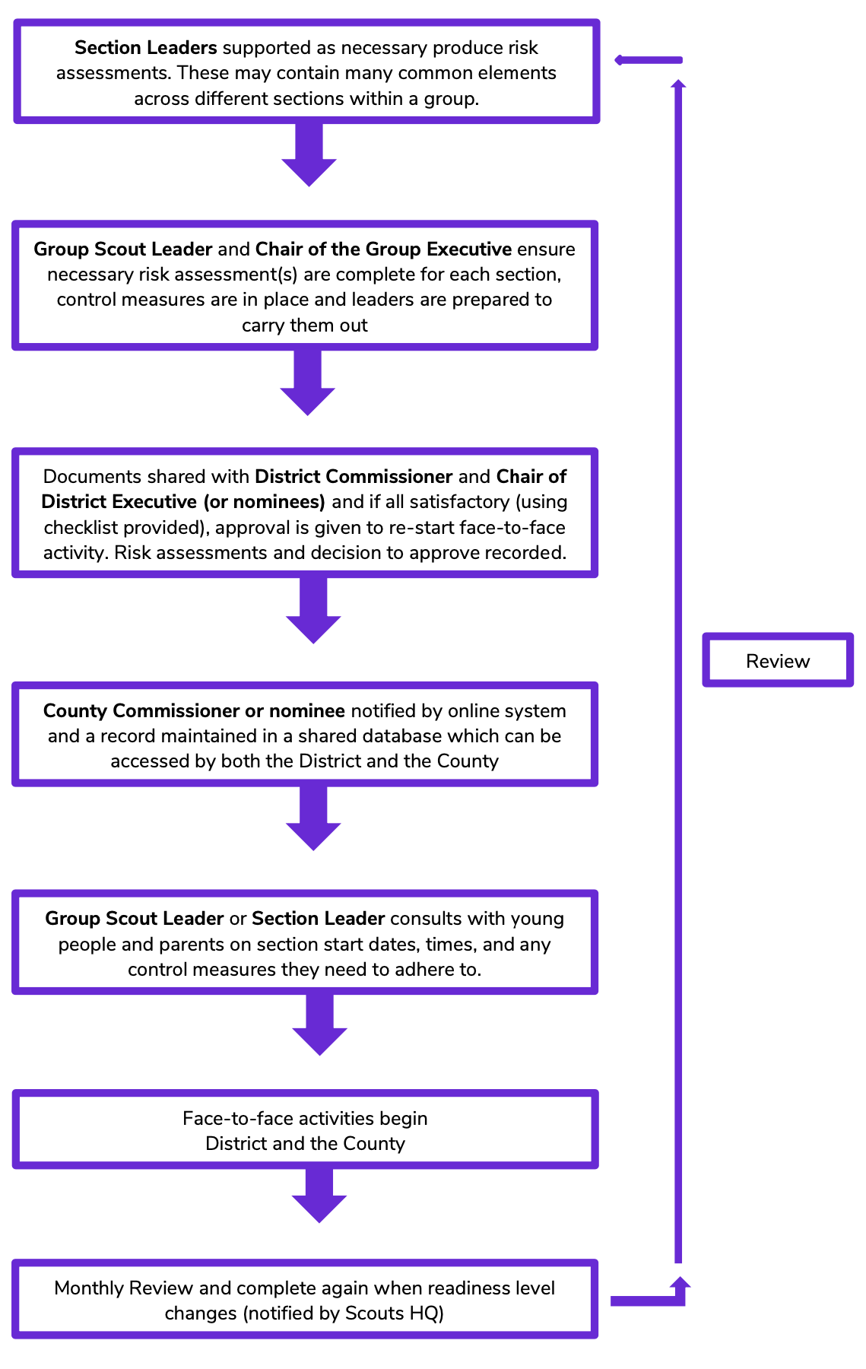
Further information and guidance can be found on The Scouts web pages here.
Getting back together
safely: The COVID Code
1. A COVID-safe risk assessment has been
completed and we have communicated control
measures to volunteers, young people and
parents/carers, and all are encouraged to raise
concerns.

2. Additional hygiene measures are in place.

3. Social Distancing will be observed (check
current distance determined by your
Government).

4. Maximum group sizes will be limited and
determined by scouts.org.uk and members will
be consistent where possible.

5. Make adjustments for young people and adults vulnerable or affected by COVID, and consult to make sure return plans are accessible and inclusive.

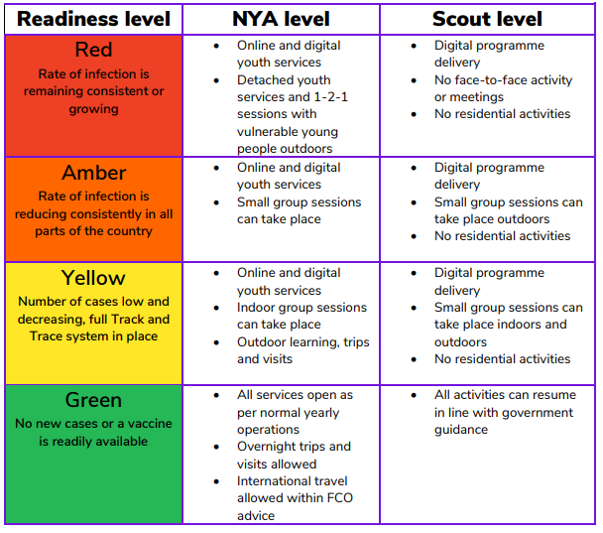

The South Yorkshire approach
Why we are doing this – the rationale and core information.

With so much information available and many different resources being created on social media, we felt as a County it was important to support our Groups in their efforts to return to face to face Scouting. In producing these documents, the following steps were taken.

- District Commissioners and District Chairs consulted and agreed to a County wide consistent approach.
- A working group of select volunteers, each with expertise in risk assessments convened.
- The working group reviewed and amended the documentation.
- Documentation sent to CC and County Chair for approval.
- DCs circulate to GSLs who are also notified of their District level assessor.

A copy of all the risk assessments produced will be held in a central record with The Scouts and can be accessed by both the District and County.

Remember a risk assessment will need to be completed for each section and additional risk assessments will need to take place if activity is planned in a significantly different location e.g. a Scout activity centre compared to a public sports field. Adult volunteers also need to be included in the maximum number of group size.

In the table below are the requirements for approval and who needs to complete the risk assessments.

Event | Prepare RA | Checker | Approval | Notified and Recorded
Beaver Section meetings/activities | Section Leaders | GSL and Group Exec | DC and District Executive | CC
Cub Section meeting/activities | Section leaders | GSL and Group Exec | DC and District Executive | CC
Scout Section meeting/activities | Section Leaders | GSL and Group Exec | DC and District Executive | CC
Explorer Section meeting/activities | Section Leaders | DESC | DC and District Executive | CC
Group Events or activity | Activity lead | GSL and Group Exec | DC and District Executive | CC
District Event or activity | Activity lead | DC and District Exec | CC and County Exec | RC
District campsite Opening | Campsite team | DC and District Exec | CC and County Exec | RC
County Event or activity | Activity lead | CC and County Exec | Regional Commissioner | HQ Safety Team
County Campsite opening | Campsite team | CC and County Exec | Regional Commissioner | HQ safety Team

The RA Checker will then go online to the ‘Guidance to leaders’ page and complete all sections in RA smart sheet, then attach the RA and submit. The Approver will receive a notification of the RA awaiting approval and a smart sheet to complete to approve or decline. Once approved then the CC will be automatically notified.
Once the Risk Assessment has been reviewed and approved then that Section can restart face-to-face activity.
When levels change Scout Groups will need to revisit and, if necessary, update their written risk assessments. They will also need to gain permission from the Approval Commissioner to enter the next readiness phase. However, if the readiness level escalates (e.g. Amber to Red), Groups will revert back to previous practice immediately and notify line-managers, rather than ask for approval.
There is no rush, and this is not a competition to return first please aim to ensure a safe return to Scouting for all.
The support
Example risks and controls
Risk | Action/Control/Suggestions
People
Volunteers not aware of the Getting back together safely guidance at scouts.org.uk | Ensure everyone reads or is briefed on the relevant guidance of getting back to scouting safely.
Uncertainty amongst volunteers, parents / carers and young people of how return to Scouting will be implemented. | Agree a communications plan and consult with all those involved in the return to face-to-face Scouting.
Parents don’t consent to face to face Scouting provision. | Explicit consent required from parents for young people to return.
Lack of enough volunteers to run sessions safely and within ratios. | Look to buddy up with other sections / groups to deliver a quality and safe programme but needs to avoid mixing bubbles.
Volunteers, young people or parents shielding. | Talk with them and agree appropriate adjustments to ensure the young people and volunteers can still be engaged, and Scouting remains accessible and inclusive to all.
Difficulties talking to potential new volunteers. | Agree a safe process for engaging and supporting those expressing an interest in volunteering.
Volunteer Training out of date. | Check and ensure all adult volunteer’s DBS and mandatory training are up to date. There is a 90 day window from 6th July to complete out of date DBS checks. Volunteers without safety and safeguarding will not be permitted to return to face to face Scouting.
Programme
Lack of flexibility of programme. | Ensure programme can be delivered both at home and face-to-face. Consider changes to programme i.e. activities that don’t involve food prep, games involving feet rather than hands.
Injury, Incident or Covid 19 symptoms. | Agreed what to do if there is an incident, someone is injured or shows of Covid 19 during face to face scouting.
Limited capacity if running sessions for smaller groups. | Do leaders have capacity for extra sessions or do you run alternate weeks, with activities to be carried out at home for those alternate weeks?
Return not youth shaped. | Ensure young people and young leaders considerations form part of the RA prepare team.
Perception
Damage to Scouting reputation. | Ensure RA’s regularly reviewed, and volunteers understand the value of dynamic risk assessments during an activity.
Meeting
Premises owner not permitting Scouting to use building. | Work with other groups, district, campsites to seek temporary accommodation.
Maintaining social distancing at drop off and pick up. | Clear expectations briefed, staggered arrival / pick up. No parents / carers to enter the building.
Maintaining social distancing during evening. | Limit group sizes, maintain and mark clear space between groups.
Hygiene of people. | Provide hand sanitiser / hand washing for members on arrival, departure and during.
Hygiene of toilets: higher risk of infection spread if hygiene not carried out. | Toilet facilities cleaned before and after sessions, cleaning equipment available to leaders with safe storage. Deep cleaning of the facility on a regular basis.
Hygiene of activity equipment: Higher risk of infection spread if hygiene not carried out. | Cleaning activity equipment before and after group use, assigning specific items to individuals for the evening, limiting volume of equipment used.
Use of outdoor space to which access can’t be controlled / area can’t be cleaned. | Choice of location appropriate to activity, briefing to volunteers and young people of boundaries, hand washing facilities and safeguarding measures.
Rented out Scout building to other users. | Implemented guidance on ‘managing and making scout premises safe’.
Track and Trace requirement connected to section meeting / event. | Set up a process for recording all attendance for each face to face session, including adults and keep it secure for 6 weeks.

The support
Useful resources and information
Area | Link to National support and guidance | Link to National FAQs
Framework for face to face activities. | The Scouts framework for returning to face to face outlined. This includes the different stages of readiness. | Link to the FAQs already provided by member feedback.
Planning a safe and enjoyable programme. | Guidance on the programme that can be offered and how this can linked to blended Scouting. | Link to the FAQs already provided by member feedback.
Speaking with parents, carers and young people. | Guidance on how to communicate with parents including sample parent letters. | Link to the FAQs already provided by member feedback.
Getting everyone there safely. | Guidance on transport to and from meetings, inclusion and capacity. | Link to the FAQs already provided by member feedback.
Working safely with the public. | Guidance on using public spaces and working with the public. This includes relevant guidelines and insurance. | Link to the FAQs already provided by member feedback.
Knowing what to do if something goes wrong – including first aid. | Guidance on what first aid provisions are in place, and other first aid considerations. | Link to the FAQs already provided by member feedback.
Supporting those made more vulnerable by the crisis. | Guidance on shielding and social distancing. The importance of having supportive discussions with parents and young people. | Link to the FAQs already provided by member feedback.
Protecting ourselves and others. | Guidance on hygiene measures that will need to be considered including hand washing. | Link to the FAQs already provided by member feedback.
What to do when our buildings are used by others. | Guidance on sharing your building with others and the steps to take to minimise risk. This includes advice on cleaning. | Link to the FAQs already provided by member feedback.
Keeping our buildings safe and secure. | Guidance on keeping our buildings safe including maintenance and hygiene. | Link to the FAQs already provided by member feedback.
Finding a safe place to meet. | Guidance on finding a suitable location to meet and the factors to consider in making this decision. | Link to the FAQs already provided by member feedback.
Getting Scouts back into the great outdoors – campsites and activity centres. | Guidance for reopening our campsites and activity centres in a safe and controlled manner. | Link to the FAQs already provided by member feedback.
Guidance for Leading and participating in the Duke of Edinburgh’s Award during the pandemic. | Guidance for supporting young people in completing their D of E awards. | Link to the FAQs already provided by member feedback.
Other useful first aid advice | Link to Government advice on first aid. This is to support the information already referred to above. | N/A

The support
Example Risk Assessment
Hazard Identified? /  Risks from it? | Who is at risk? | How are the risks already controlled?  What extra controls are needed? | What has changed that needs to be thought about and controlled?
Hazard – something that may cause harm or damage.  Risk – the chance of it happening. | Young people,  Leaders,  Visitors? | Controls – Ways of making the activity safer by removing or reducing the risk from it.  For example - you might use a different piece of equipment or you might change the way the activity is carried out. | Keep checking throughout the activity in case you need to change it…or even stop it! This is a great place to add comments which will be used as part of the review.
Meeting place, selection of suitable outdoor location(s) for meetings that allow compliance with current social distancing requirements. Other general safety issues that affect suitability including access, ease of controlling activities, public or private access, on-site facilities. | All leaders, volunteers and members | Group exec to consult with landlord about use of outdoor spaces if these are attached to regular meeting space, and ascertain their fitness for use.  Leaders to agree with Exec if using outdoor spaces away from normal meeting location.  For new sites Leaders to carry out site visit and complete site specific risk assessment for activities.  For sites used previously Leaders to review existing site specific risk assessment for activities. | The following outdoor space at regular meeting location can be used:  The following public locations can be used:
Inadequate local planning results in gaps in operating procedures, increased risk of infection as other risks listed here not being adequately addressed. | All leaders, volunteers and members | Group exec to develop local safe operating procedures (SOP) for Covid with section leaders to ensure coverage of all issues and consistency across the sections.  GSL to obtain DC approval for restart of F2F scouting.  Group exec / GSL to ensure SOPs are briefed out to section leaders and incorporated into their meeting planning and operation.  Section leaders to plan Covid safe programme activities. | Group Standard Operating Procedures (SOP) are agreed and available from:  DC approval has been given for the following:  GSL has agreed Covid safe programmes for:
Meeting timings. Scheduling with other sections and users if using private outdoor spaces. Unable to maintain social distancing at drop off, pick up and during activity.  If using public outdoor spaces, consider that other groups may also be using same space. | All leaders, volunteers and members | Execs / GSL to liaise with landlord regarding access to outdoor spaces and meeting start and finish times.  New timings e.g. staggered to be adopted to allow social distancing to be maintained at pick up and drop off particularly between different sections or building user groups.  For public outdoor spaces have a flexible pick up and drop off plan that can be adapted if area is busy with other groups. | Meeting times for each section have been agreed as follows:  Pick up and drop off location will be:
Engagement with parents and members to ensure understanding of changes to operation of meetings. Failure to observe social distancing and higher risk of infection if new arrangements not understood | All leaders, volunteers and members | Section leaders to review Group safe operating procedures and adapt to their section.  Section leaders to provide relevant information to parents and members on changes to meeting operation to minimise Covid risks.  Provide written instructions to parents (and members in scouts and explorers).  Explain during virtual meeting or through Facebook video, give opportunity for parents to ask questions. | Section has adopted / adapted the group SOP:  Parents have received written instructions on conduct of Covid safe meetings with the programme:  Virtual meeting for parents and members took place on:
Ensuring adequate volunteers e.g. leaders, helpers, parents, etc. available to prepare and operate for meetings.  Reduced pool of volunteers to draw upon, e.g. due to shielding, personal choice on risks, BAME, etc. Insufficient volunteers results in failure to maintain hygiene, inability to supervise social distancing amongst members and higher risk of infection spread. | All leaders, volunteers and members | GSL, Section Leaders to review Covid SOPs and determine what number of volunteers are required to run meetings e.g. normal to run meeting and extra, as required, to assist with maintaining social distancing or hygiene.  GSL to consult with all regular volunteers and establish who is willing and able for F2F meetings.  GSL to have private discussions with volunteers who are known or make known that they are shielding, at increased risk, e.g BAME, other health conditions, or raise concerns.  GSL to signpost information on Covid risks to allow personal choices to be made on whether to return to volunteering.  Where required GSL to seek additional volunteers e.g. from amongst parents.  Provide copy of risk assessment, safe operating procedure and give an onsite briefing for any new volunteers.  Allow adequate time for briefing on SOP ahead of meetings with members. | GSL has consulted on volunteers available:  Section has sufficient leaders to operate:  Section requires additional volunteers:  Risk assessment and SOP has been made available to existing and new volunteers:
Maintaining social distance at drop off and pick up. Higher risk of infection spread if social distancing not maintained. | All leaders, volunteers and members | Organise drop off and pick up to maintain social distancing.  Parents and members to line up, consider use of markers for social distancing or provide additional supervision. | Drop off and Pick up location will be at:  Additional arrangements are as follows:
Hand hygiene on arrival. Higher risk of infection spread if hygiene not carried out. | All leaders, volunteers and members | Instruction to all members to wash hands before leaving home for meetings.  Make clear to parents whether toilets will be available at outdoor location  Provide hand sanitiser as members arrive or members to wash hands in toilets if available  If washing hands, provide supervision to maintain social distancing in and out of toilets and for younger members supervision to ensure proper washing and drying.  Allow extra time if hand washing. | Toilets are / are not available  Hand sanitiser has been sourced
Maintaining social distance during meeting. Higher risk of infection spread if social distancing not maintained. | All leaders, volunteers and members | Organise meeting location and activity to maintain social distancing.  Consider use of markers on ground for social distancing,  Decide on how leaders will conduct the meeting e.g. from the front, to maintain social distancing. | Programme activities have been reviewed for social distancing and group size.
Hygiene of activity equipment. Higher risk of infection spread if hygiene not carried out. | All leaders, volunteers and members | Ask members to bring their equipment where practical.  Avoid use of activity equipment where practical  Section Leaders to consider how activity equipment will be sanitised before or after use when planning programme  Wash or wipe down items that are easy to clean with hot water and detergent or sanitiser wipes.  Only put out minimum required consumables e.g. paper, for activity.  Dispose of anything left behind in normal domestic waste.  Some items cannot be easily sanitised e.g. ropes, tennis balls, substitute, or consider additional hand hygiene if these items are required for activities or quarantine items for 3 days. | Cleaning materials are available
First Aid. Giving first aid requires social distance guidelines to be broken, facial contact for mouth to mouth. | All leaders, volunteers and members | Add surgical masks, aprons and resuscitation face shields to first aid kits.  For minor injuries on teenagers and adults encourage self treatment to maintain social distancing.  If breaking social distancing first aider and casualty to don surgical masks (not for facial injuries or where breathing is affected)  For resuscitation use a face shield or give mouth to mouth as normal (priority into preserve life, risk from virus is low compared to certain death if resuscitation is not attempted). | Additional items added to first aid kits  Discussion with leaders on first aid procedures  Mouth to mouth should only be done if you feel it is safe to do so and has been assessed as such (call 999 if in doubt).
Mental health and wellbeing affected through isolation or anxiety about coronavirus | All leaders, volunteers and members | Have regular keep in touch meetings/calls with leaders and scouts who cannot join F2F meetings.  Talk openly with scouts about well-being and who to talk to.  Involve all adults in implementing and reviewing risk assessments so they can help identify potential problems and identify solutions.  Brief scouts about risks appropriately. Keep leaders and scouts updated on what is happening so they feel involved and reassured | Virtual meetings on programme with F2F
Review: This risk assessment is for a group to move from one covid alert level to the next, an additional risk assessment should be produced for each move proposed.

